**JOYFUL JOURNEY Application**

**Technologies used:**

**Frontend**-visual studio and React

**Backend**-Intellij Springboot

**Database** -MySQl and MYSQL workbench

Joyful Journey system is a software application or platform designed to facilitate the booking of bus tickets by passengers. It streamlines the process of ticket booking, seat selection, payment processing, and managing reservations for bus travel.

1. **Bus Routes and Schedules:** It provide information about various bus routes, schedules, departure times, and arrival times for passengers to choose from.
2. **User Interface:** The system should have an easy-to-use interface for passengers to search for available buses, select departure and arrival locations, choose travel dates, and view seat availability.
3. **Seat Availability:** The system display seat availability for each bus trip, allowing passengers to select preferred seats from the available options.
4. **Booking and Reservation:** Passengers is able to make reservations and book tickets for their desired bus trips through the system. This includes providing passenger details, selecting seats, and confirming the booking.
5. **Seat Selection:** Passengers should be able to choose their preferred seats from an interactive seating layout displayed during the booking process.
6. **User Accounts:** Registration and login functionality for passengers to create accounts, manage their bookings, view booking history, and update personal information.
7. **Admin Dashboard:** An administrative interface for bus operators or system administrators to manage bus schedules, add or remove Bus, configure ticket prices, view bookings, generate reports, and perform other administrative tasks.
8. **Security:** Implement Jwt security measures to protect user data, secure payment transactions, and prevent unauthorized access to the system.

**Project setup:**

Steps to download frontend project from GitHub in VS code

1. You can do this by pressing Ctrl + Shift + P (Windows/Linux) or Cmd + Shift + P (Mac). This will open a command palette at the top of the editor.
2. Clone Repository: In the command palette, type Git: Clone and select the option that appears. Alternatively, you can press Ctrl + Shift + P (Windows/Linux) or Cmd + Shift + P (Mac) and type Git: Clone and press Enter.
3. You will be prompted to enter the URL of the GitHub repository you want to clone. Paste the URL and press Enter.
4. Choose the local directory where you want to clone the repository. Once selected, press Enter.
5. If the repository is private or requires authentication, you may be prompted to provide your GitHub username and password or personal access token. Enter the required credentials and press Enter.
6. VSCode will start cloning the repository from GitHub to your local machine. You will see a progress indicator in the status bar at the bottom of the editor.
7. Once the cloning process is complete, VSCode will open the cloned repository in a new window automatically.
8. Enter online-bus-ticket-booking
9. And type npm dev command.

10.Open browser with <http://localhost:3000/>

**Steps to download backend project from GitHub in VS code**

1. Open the Project from Version Control: In the IntelliJ IDEA welcome screen, or if you have an existing project open, you can go to File > New > Project from Version Control > Git.

2. Clone Repository: In the URL field, enter the URL of the GitHub repository you want to clone. You can find this URL on the GitHub repository page. Then click Clone.

3. Select Destination Folder: Choose the local directory where you want to clone the repository. Once selected, click Clone.

4. Authenticate (if required): If the repository is private or requires authentication, IntelliJ IDEA will prompt you to provide your GitHub username and password or personal access token. Enter the required credentials and click OK.

5. Wait for Cloning to Complete: IntelliJ IDEA will start cloning the repository from GitHub to your local machine. You will see a progress indicator in the bottom right corner of the IntelliJ IDEA window.

6. Open Cloned Project: Once the cloning process is complete, IntelliJ IDEA will open the cloned project in a new window automatically.

7. Configure Project Settings (if necessary): Depending on the project, you may need to configure additional settings such as SDK, project structure, dependencies, etc.

8. Run onlineBusTicketBooking file

9. Its runs in <http://localhost:8081>

**Application.properties:**

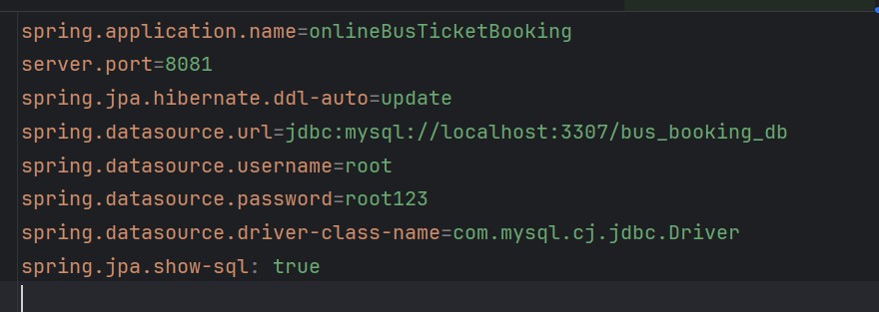

**MySQL work bench set up(And add all the comments given below)**

create database bus_booking_db;

use bus_booking_db;

1. insert into users(email,name,password,username)values("admin@gmail.com","admin","$2a$10$I37gLqFeG9jChqTIOVZ5I.p4QQsQ4wg09l4GPaj.Idq7rF3NktD4a","admin");
2. insert into users(email,name,password,username)values("john@gmail.com","user","$2a$10$QqOYzn2PdXYcAg6xCqrhFOMDJDk8ioW2WCDPn7A0rUAcdjmptO7Pu","john");
3. insert into roles(name)values("ROLE_ADMIN");
4. insert into roles(name)values("ROLE_USER");
5. insert into users_roles values(1,1);
6. insert into users_roles values(2,2);

**Login credentials:**

**Admin**

Username: admin

Password: admin

**Username**

Username: john

Password: john

You can add user by registering the user to login but admin credentials cannot be changed.

**Screenshots of Joyful Journey System:**

**Homepage(“/”):**



**About us(“/about”):**



**Contact(“/contact”):**

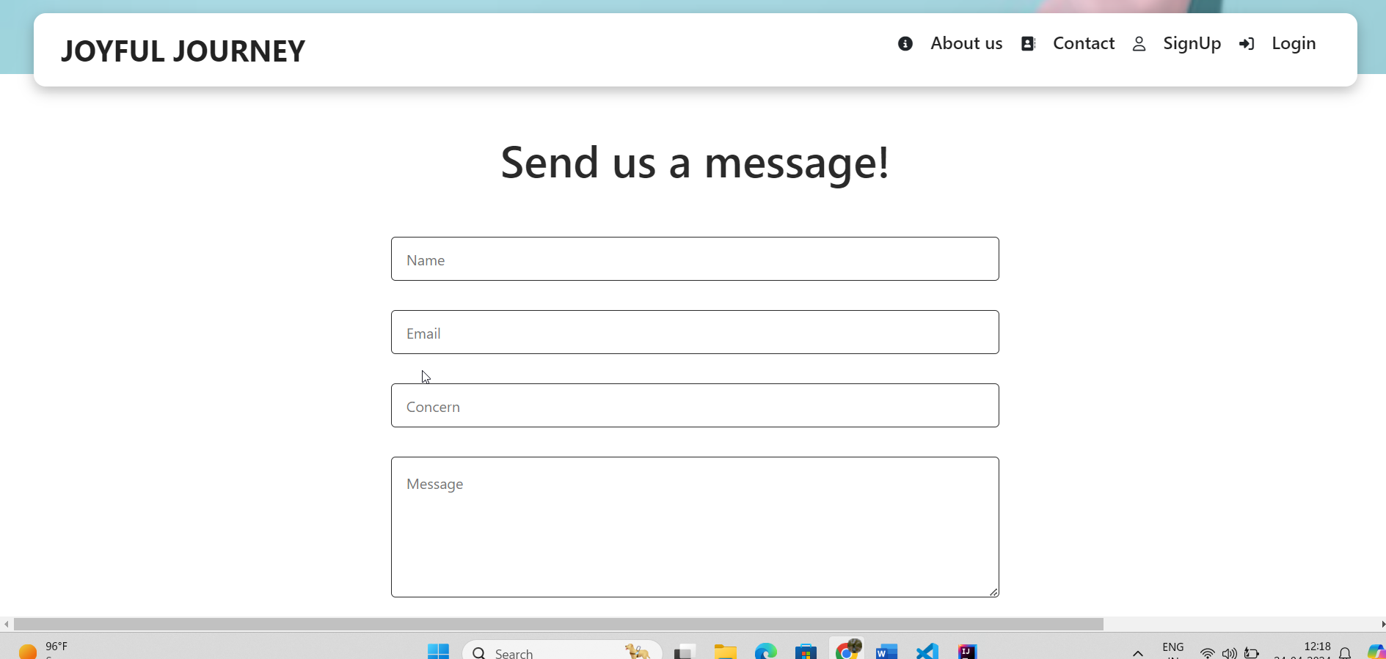

**Login(“/login”)**

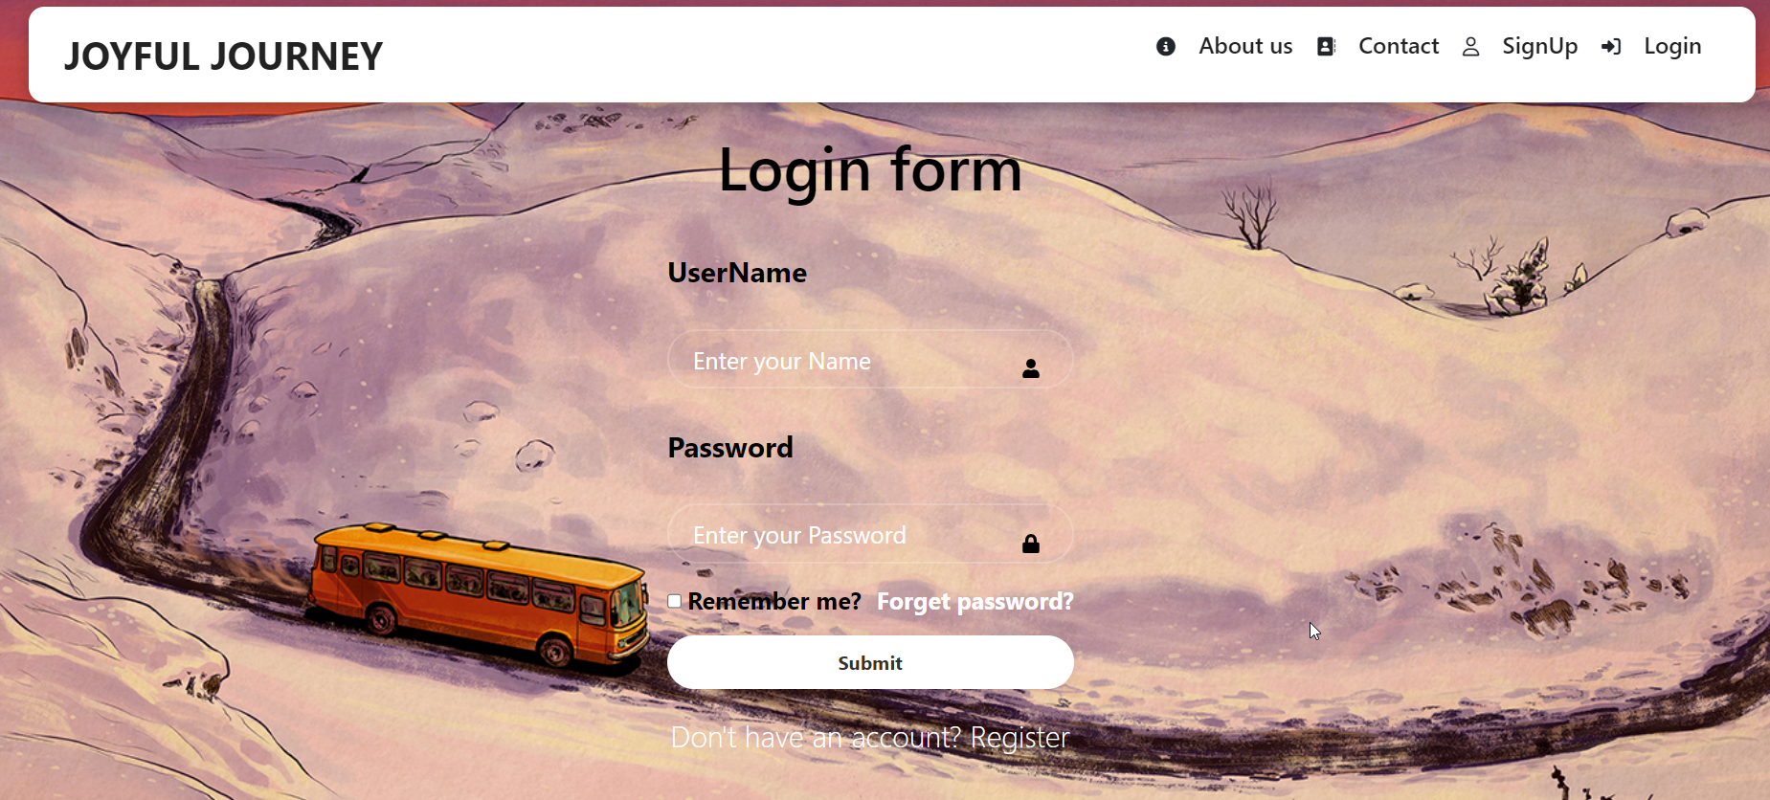

**SignUp(“/signup”)**

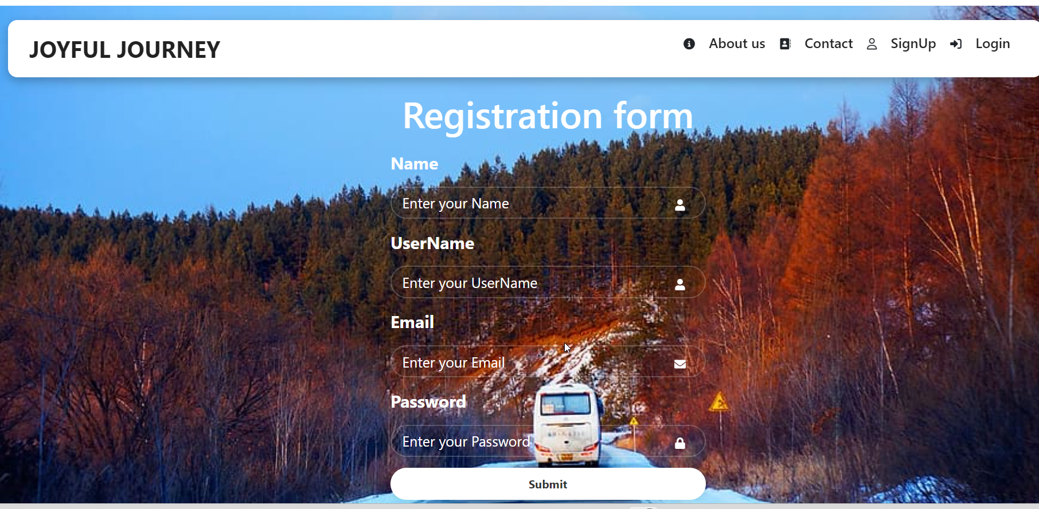

**Admin DashBoard(“admin”)**

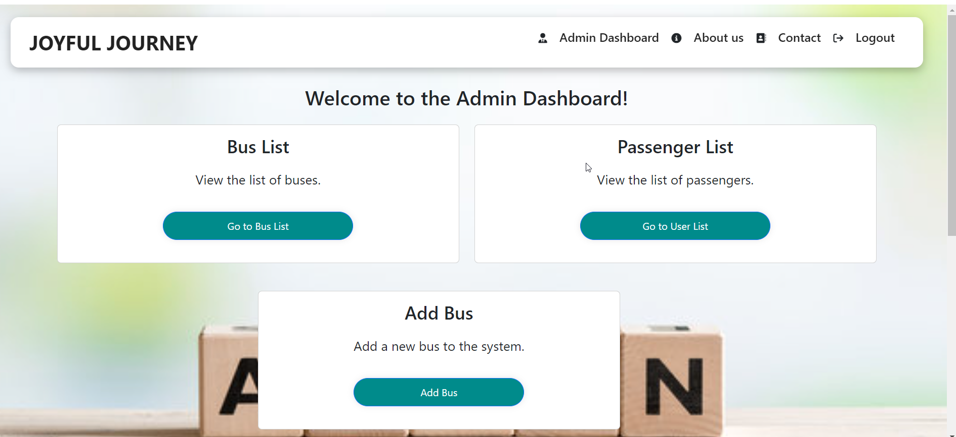

**BusList(“/listbus”)**

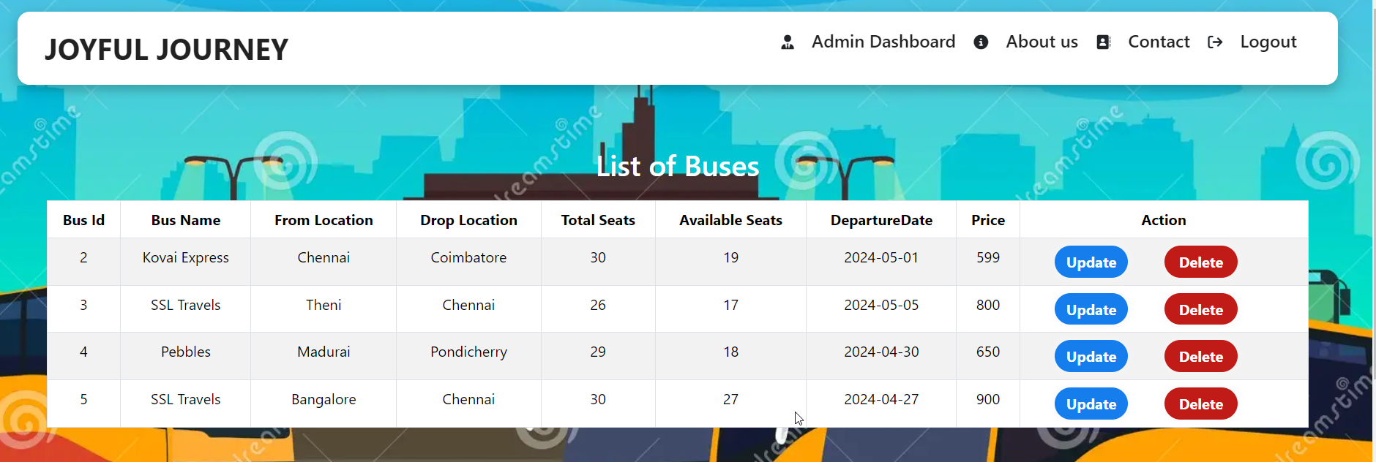

**PassengerList(“listpassenger”):**

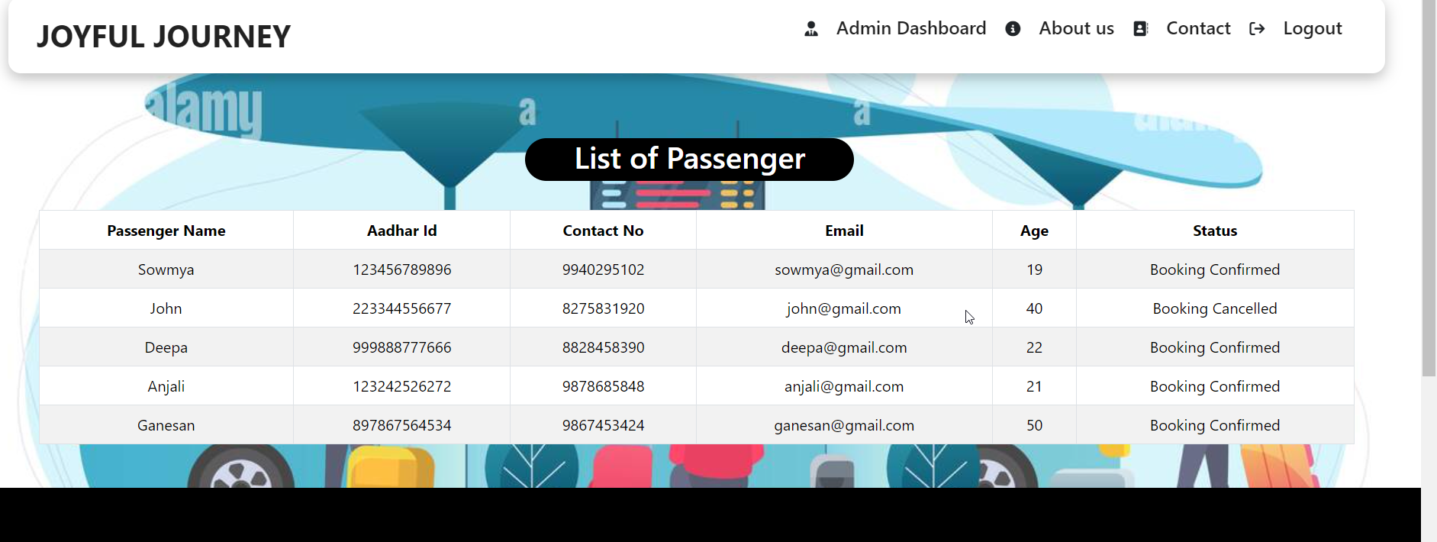

**AddBus(“/addbus”):**

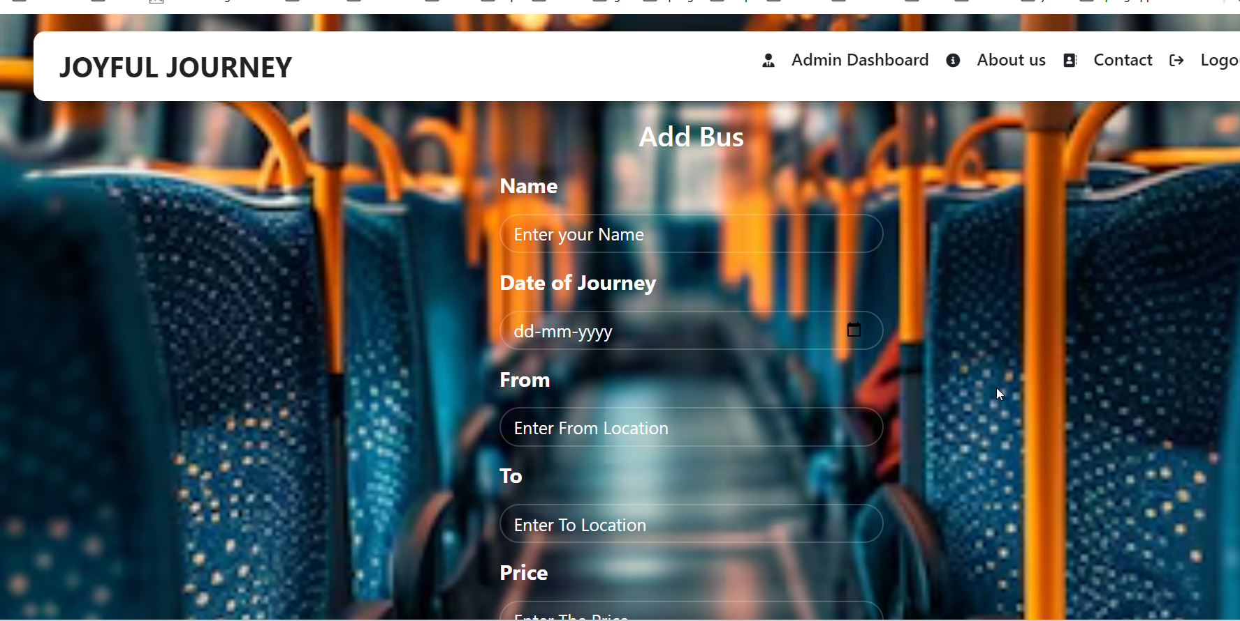

**UserLogin:**

**Destination(“/destination”):**

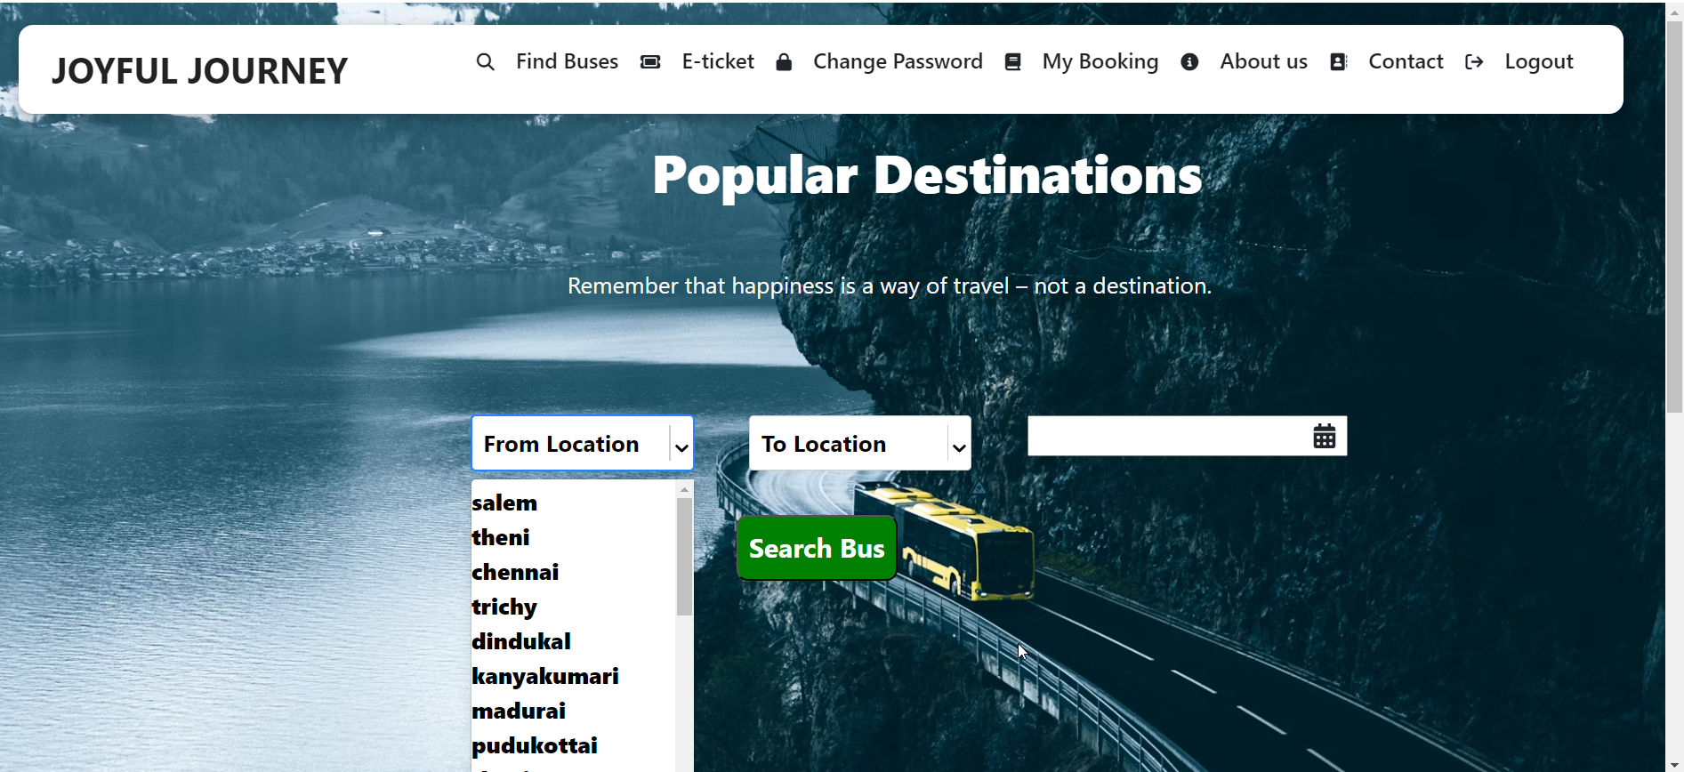

**After Clicking search:**

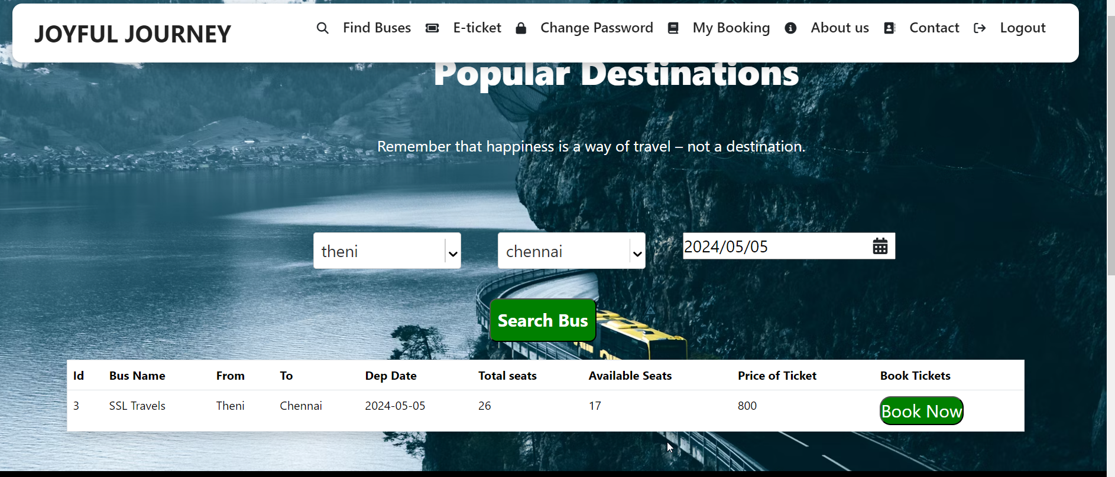

**Seat(“/seatlayout/:id”):**

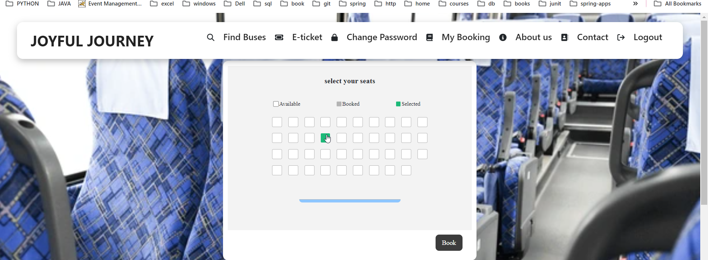

**Booking(“/bookNow/:id”)**

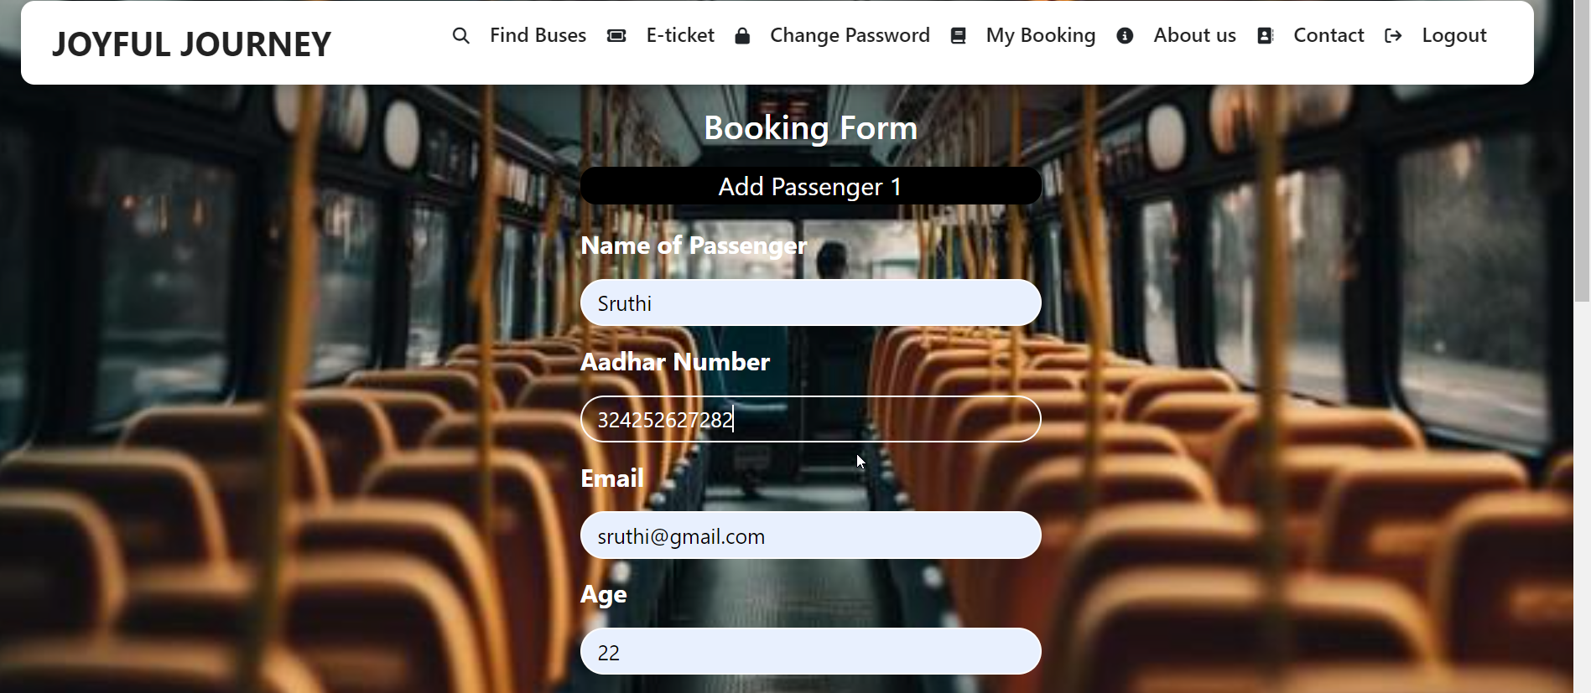

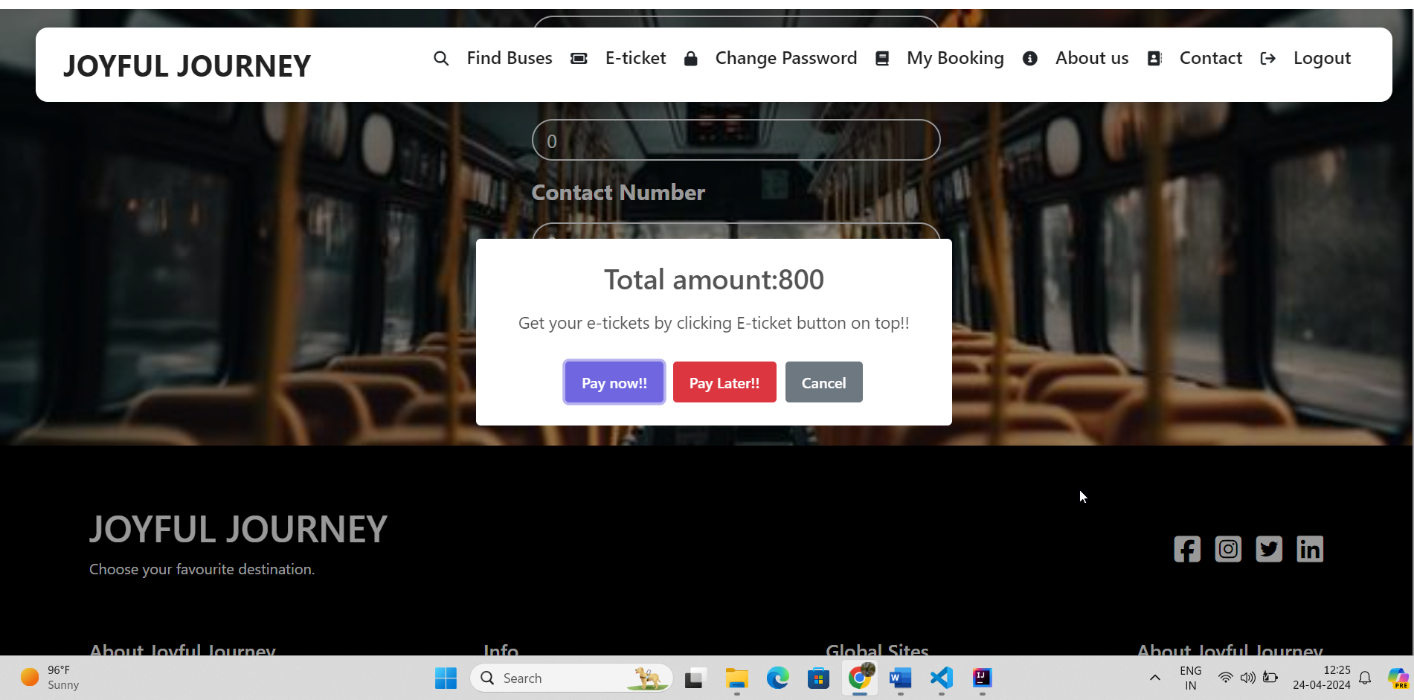

**MyBooking(“/mybooking”):**

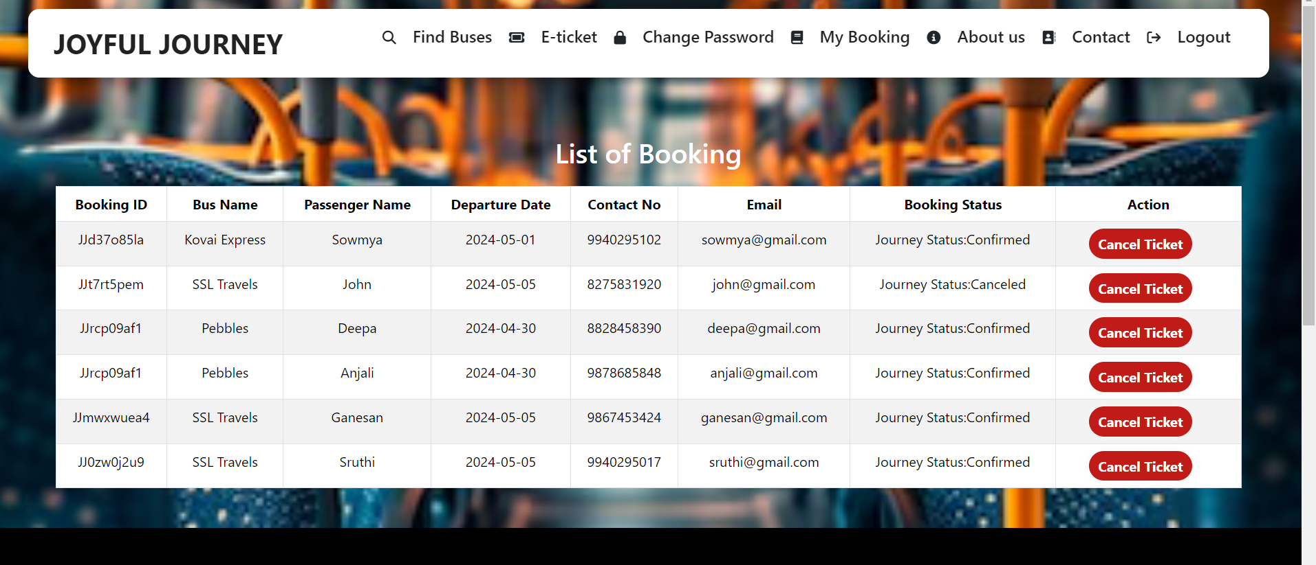

**View Ticket (“/view/:id”):**



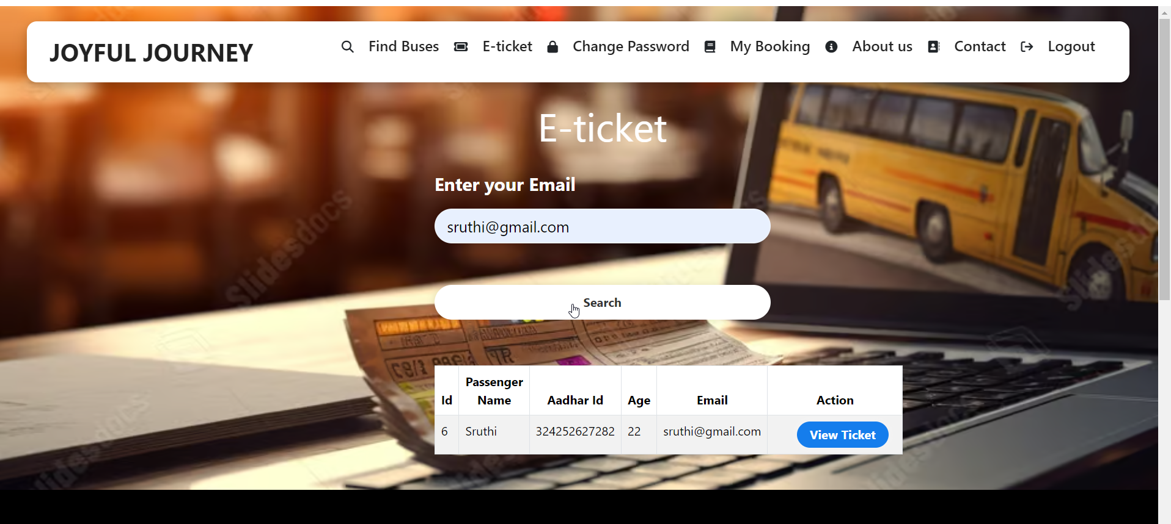

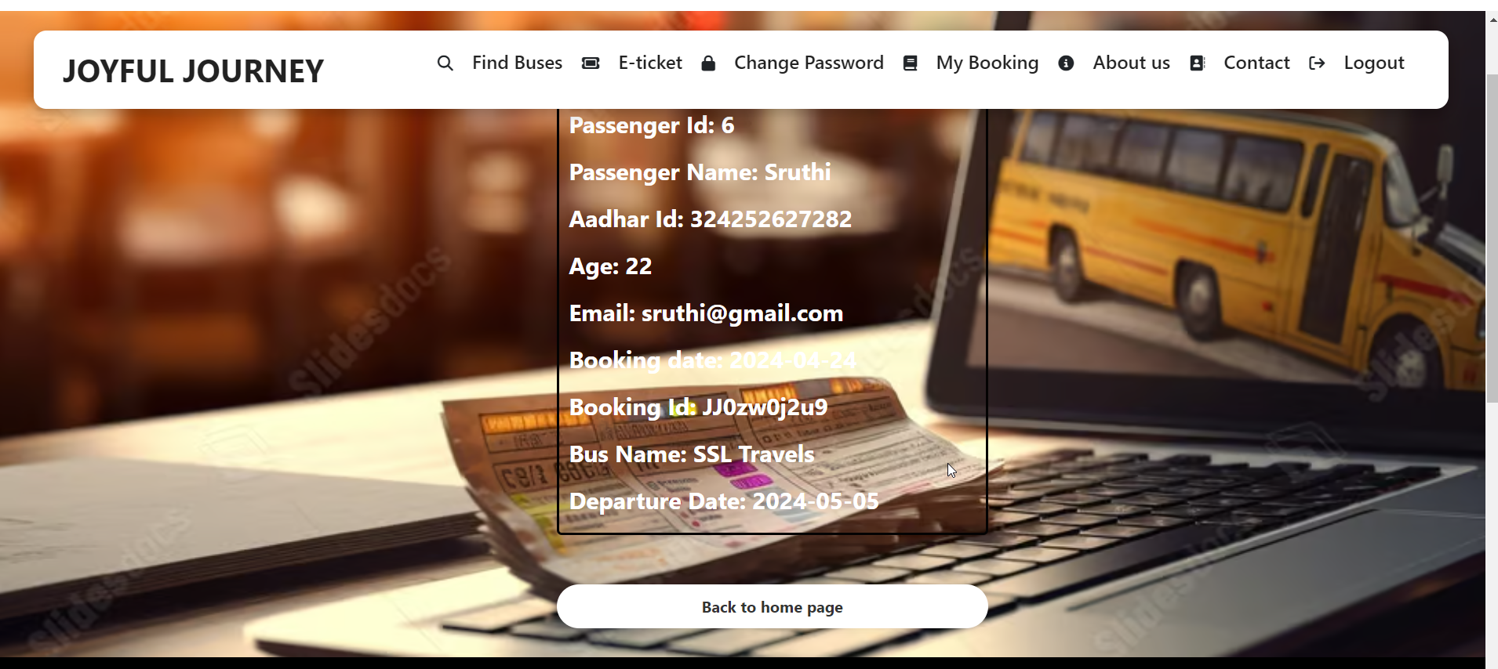

**Change Password** **(“/changePassword”)**

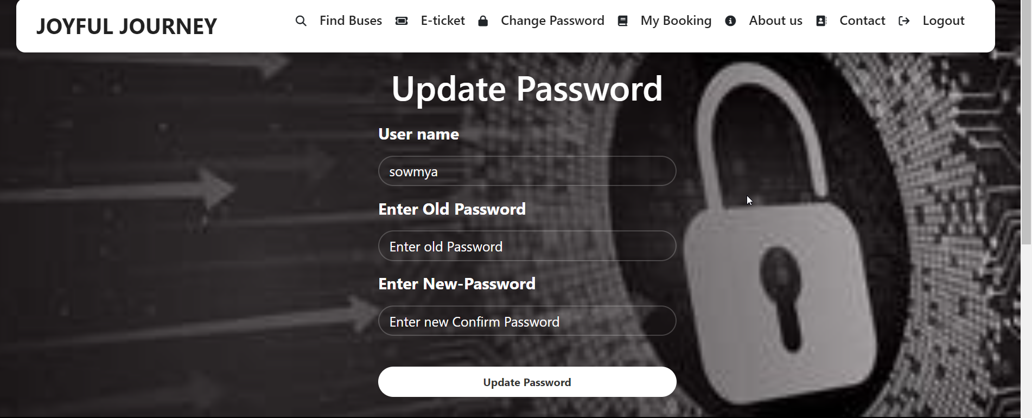

**Footer:**

